Hitachi Virtual Storage Platform 360
v1.2

Implementation Guide

This implementation guide describes the integration of Hitachi Virtual Storage Platform 360 (VSP 360) with CyberArk’s REST API CPM Plugin Framework to enable secure, automated privileged credential management. It outlines the prerequisites, plugin configuration structure, and REST API interaction logic, including token-based authentication for secure access. The guide follows CyberArk REST API plugin standards to ensure compatibility, maintainability, and secure handling of credentials within the VSP 360 platform.

Hitachi Vantara

February 2026

© 2025 Hitachi Vantara Ltd. All rights reserved.

No part of this publication may be reproduced or transmitted in any form or by any means, electronic or mechanical, including copying and recording,
or stored in a database or retrieval system for commercial purposes without the express written permission of Hitachi, Ltd., Hitachi Vantara, Ltd., or
Hitachi Vantara LLC (collectively “Hitachi”). Licensee may make copies of the Materials provided that any such copy is: (i) created as an essential step
in utilization of the Software as licensed and is used in no other manner; or (ii) used for archival purposes. Licensee may not make any other copies of
the Materials. “Materials” mean text, data, photographs, graphics, audio, video and documents.

Hitachi reserves the right to make changes to this Material at any time without notice and assumes no responsibility for its use. The Materials contain
the most current information available at the time of publication.

Some of the features described in the Materials might not be currently available. Refer to the most recent product announcement for information about
feature and product availability, or contact Hitachi Vantara LLC at https://support.hitachivantara.com/en_us/contact-us.html.

Notice: Hitachi products and services can be ordered only under the terms and conditions of the applicable Hitachi agreements. The use of Hitachi
products is governed by the terms of your agreements with Hitachi Vantara LLC.

By using this software, you agree that you are responsible for:

1. Acquiring the relevant consents as may be required under local privacy laws or otherwise from authorized employees and other individuals; and

2. Verifying that your data continues to be held, retrieved, deleted, or otherwise processed in accordance with relevant laws.

Notice on Export Controls. The technical data and technology inherent in this Document may be subject to U.S. export control laws, including the
U.S. Export Administration Act and its associated regulations, and may be subject to export or import regulations in other countries. Reader agrees to
comply strictly with all such regulations and acknowledges that Reader has the responsibility to obtain licenses to export, re-export, or import the
Document and any Compliant Products.

Hitachi and Lumada are trademarks or registered trademarks of Hitachi, Ltd., in the United States and other countries.

AIX, DB2, DS6000, DS8000, Enterprise Storage Server, eServer, FICON, FlashCopy, GDPS, HyperSwap, IBM, OS/390, PowerHA, PowerPC, S/390,
System z9, System z10, Tivoli, z/OS, z9, z10, z13, z14, z15, z16, z/VM, and z/VSE are registered trademarks or trademarks of International Business
Machines Corporation.

Active Directory, ActiveX, Bing, Excel, Hyper-V, Internet Explorer, the Internet Explorer logo, Microsoft, Microsoft Edge, the Microsoft corporate logo,
the Microsoft Edge logo, MS-DOS, Outlook, PowerPoint, SharePoint, Silverlight, SmartScreen, SQL Server, Visual Basic, Visual C++, Visual Studio,
Windows, the Windows logo, Windows Azure, Windows PowerShell, Windows Server, the Windows start button, and Windows Vista are registered
trademarks or trademarks of Microsoft Corporation. Microsoft product screen shots are reprinted with permission from Microsoft Corporation.

All other trademarks, service marks, and company names in this document or website are properties of their respective owners.

The open source content used in Hitachi Vantara products may be found within the Product documentation or you may request a copy of such
information (including source code and/or modifications to the extent the license for any open source requires Hitachi make it available) by sending an
email to OSS_licensing@hitachivantara.com.

Table of Contents

Table of Contents 3
Preface 4
About this document 4
Document conventions 4
Intended audience 4
Release notes 4
Revision History 4
Accessing product downloads 5
Getting Help 5
Comments 5
Overview 6
Purpose 6
Architecture Summary 6
Supported CyberArk Plugins for VSP360 7
VSP360 Service Account CPM Plugin 7
VSP360 User Account CPM Plugin 7
VSP360 Block Device Usage Plugin (VSP Block Re-registration) 8
VSP360 PSM Web Connector 9
Authentication and Authorization Model 9
Security Best Practices 9
Summary 10

Preface

About this document
This document provides detailed implementation guidance for integrating Hitachi Virtual Storage Platform 360 (VSP 360) with CyberArk’s REST API CPM Plugin Framework. It is structured to assist technical users in understanding the setup requirements, configuration structure, and supported use cases for secure and automated credential management.

Document conventions
This document uses the following typographic convention:

Convention | Description
Bold | - Indicates text in a window, including window titles, menus, menu options, buttons, fields, and labels. Example: Click OK.  - Indicates emphasized words in list items.
Italic | Indicates a document title or emphasized words in text.
Monospace | Indicates text that is displayed on screen or entered by the user.

Intended audience
The guide is intended for system administrators, security engineers, and integration specialists responsible for configuring CyberArk Central Policy Manager (CPM) to manage credentials on Hitachi VSP 360 systems.

Release notes
This section provides information about version‑specific behavior, known limitations, and changes introduced in this release. It highlights updates that may affect functionality, compatibility, or integration workflows.
All modifications to this guide including corrections, enhancements, newly added features, and procedural updates are recorded in the Revision History section for clear tracking and reference.

Revision History
Revision | Changes | Date
v1.0 | Initial release of the implementation guide for integrating Hitachi VSP 360 with CyberArk REST API plugin. | 02/02/2026

Accessing product downloads
Product software, drivers, and firmware downloads are available on Hitachi Vantara Support Connect: https://support.hitachivantara.com/.

Log in and select Product Downloads to access the most current downloads, including updates that may have been made after the release of the product.

Getting Help
Hitachi Vantara Support Connect is the destination for technical support of products and solutions sold by Hitachi Vantara. To contact technical support, log on to Hitachi Vantara Support Connect for contact information: https://support.hitachivantara.com/en_us/contact-us.html.

Hitachi Vantara Community is a global online community for customers, partners, independent software vendors, employees, and prospects. It is the destination to get answers, discover insights, and make connections. Join the conversation today! Go to community.hitachivantara.com, register, and complete your profile.

Comments
Please send us your comments on this document to GPSE-Docs-Feedback@hitachivantara.com. Include the document title and number, including the revision level (for example, -07), and refer to specific sections and paragraphs whenever possible. All comments become the property of Hitachi Vantara LLC.

Overview

Purpose
This guide describes how to integrate VSP 360 with CyberArk Privileged Access Manager (PAM) using CyberArk REST API-based CPM plugins and a PSM web connector.

The integration enables secure, automated management of privileged credentials used by VSP 360, including:
- VSP 360 service accounts (Keycloak clients)
- VSP 360 user accounts
- VSP block storage device credentials registered in VSP 360
- Privileged web access to the VSP 360 UI

The solution follows CyberArk’s REST API Plugin Framework and uses VSP 360 APIs to ensure secure credential rotation, validation, and auditability.

Architecture Summary
CyberArk PAM acts as the central authority for storing and rotating credentials. VSP 360 exposes PAM-specific REST APIs that enable CyberArk to:
- Authenticate using a VSP 360 service account.
- Rotate secrets or passwords securely.
- Update downstream credentials (such as block storage devices).
- Provide controlled privileged UI access through PSM.
All communication is performed over HTTPS, and sensitive data is never returned by GET APIs.

Supported CyberArk Plugins for VSP 360

VSP 360 Service Account CPM Plugin
Purpose:
This plugin (HitachiVSP360ServiceAccount) manages VSP 360 service accounts created using the VSP 360 Admin UI. These service accounts are Keycloak clients used for machine-to-machine authentication.

What the plugin does:
- Verifies the service account by obtaining an access token.
- Rotates the service account secret using the VSP 360 PAM API.
- Optionally reconciles the secret using a designated reconcile account.
CyberArk Account Properties:
Property | Description
Address | VSP 360 hostname or FDQN
Username | Service account Client ID
Password | Service Account Client Secret

PVWA Console Ref:
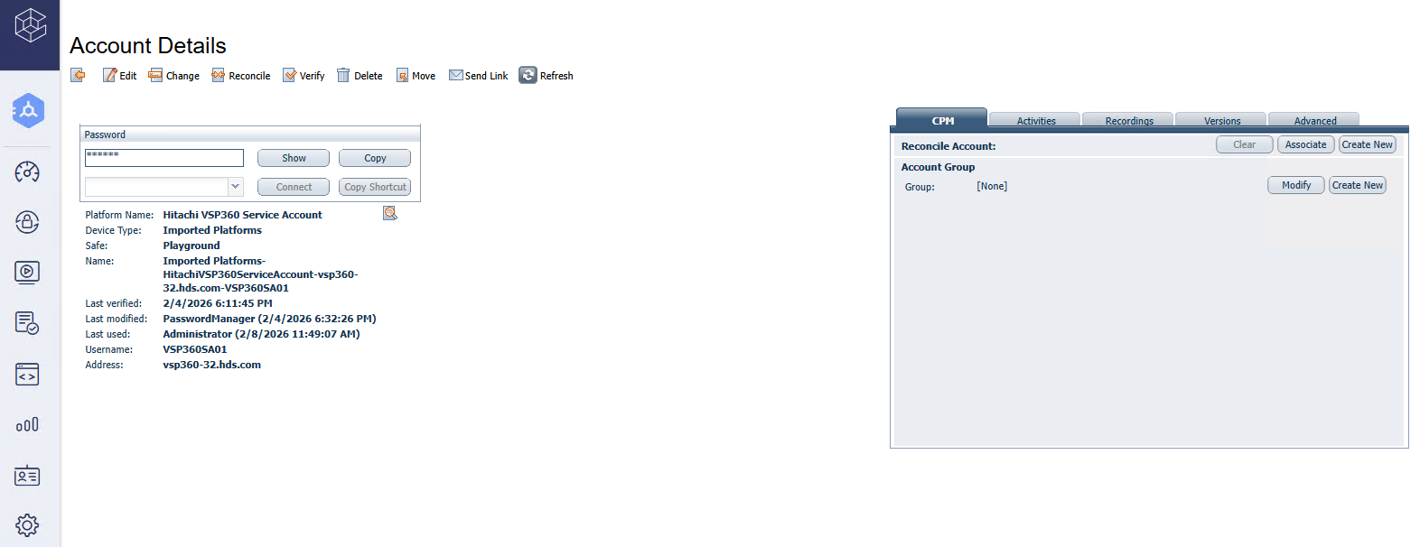

VSP 360 API Endpoints Used:
- Token generation
POST /auth/realms/vsp360/protocol/openid-connect/token
- Rotate service account secret
PUT /platform/api/v1/pam/service-accounts/{clientId}/rotate

VSP 360 User Account CPM Plugin
Purpose:
This plugin (HitachiVSP360UserAccount) manages VSP 360 user accounts by resetting passwords through a privileged service account.

What the plugin does:
- Authenticates using a VSP 360 service account.
- Updates the password of a specified VSP 360 user.
- Supports reconcile operations.

Note: This plugin supports the reconcile operation. To perform a VSP 360 user password reset, a dedicated reconcile account must be configured and linked to the target user account in CyberArk. The reconcile VSP 360 service account is used to authenticate to VSP 360 and apply the password change for the VSP 360 user.

CyberArk Account Properties:
Property | Description
Address | VSP 360 hostname or FDQN
Username | VSP 360 local username (admin, secadmin)
User Id | Unique VSP 360 user identifier
Reconcile Account | VSP 360 Service Account Client ID

PVWA Console Ref:
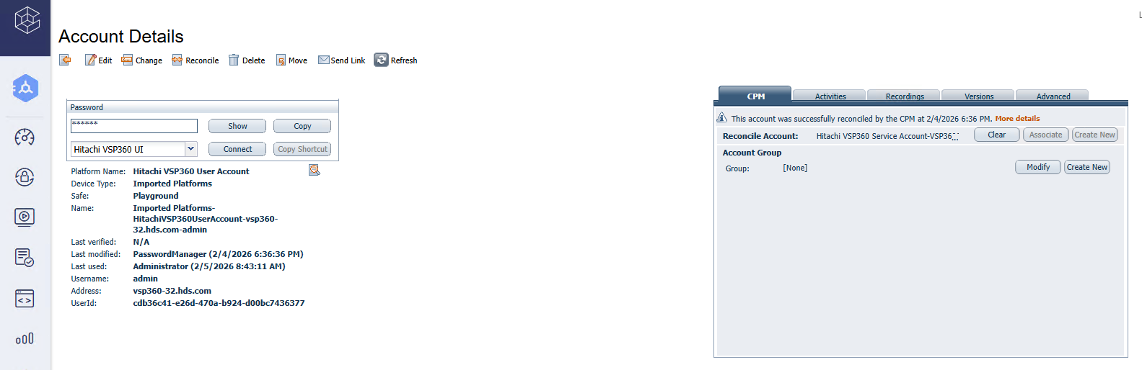

VSP 360 API Endpoints Used:
- Update user password
PUT /platform/api/v1/pam/users/{userId}/password

VSP 360 Block Device Usage Plugin (VSP Block Re-registration)
Purpose:
This usage plugin (VSP360BlockLink) updates VSP 360 whenever a VSP block storage account password is rotated in CyberArk.

What the plugin does:
- Uses a VSP 360 service account to authenticate.
- Consumes the newly rotated master account password.
- Updates the corresponding block device credentials stored in VSP 360.
- Ensures VSP 360 can continue to access the Hitachi VSP block storage system after password changes.
CyberArk Account Properties:
Property | Description
Address | VSP 360 hostname or FDQN
vsp360 Device ID | Unique Device Identifier in VSP 360
VSP Block Storage Username | Block Storage Username
Logon Account | VSP 360 Service Account Client ID

PVWA Console Ref:
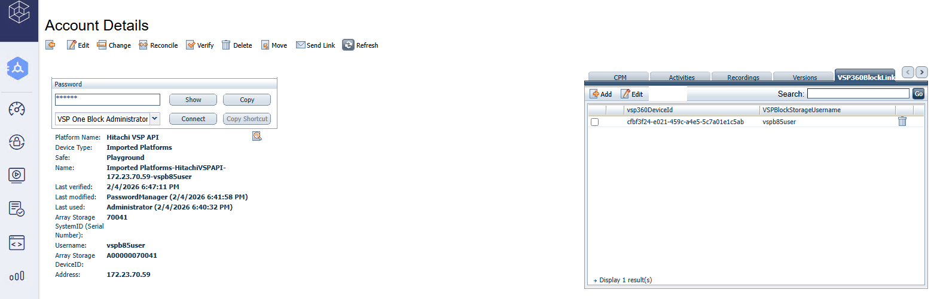
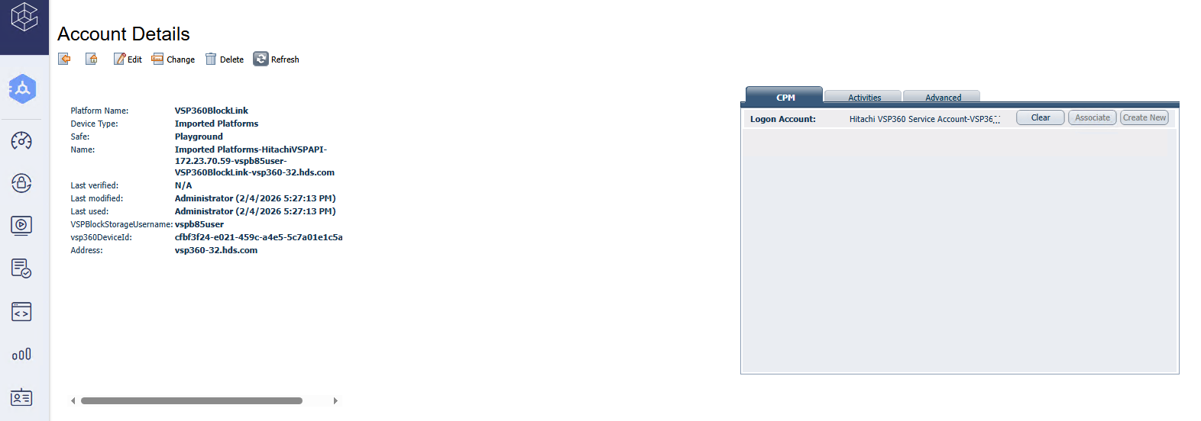

VSP 360 API Endpoints Used:
- Update VSP Block Storage device credentials
PUT /platform/api/v1/pam/devices/{vsp360DeviceId}/credentials

VSP 360 PSM Web Connector
Purpose:
The PSM connector (CC-HitachiVSP360UI) provides secure, audited privileged access to the VSP 360 web UI through CyberArk PSM.

What the connector does:
- Launches VSP 360 in a hardened browser session.
- Automatically injects credentials stored in CyberArk.
- Validates successful login using post-login DOM markers.
Key Capabilities:
- Supports multiple post-login landing pages.
- Prevents credential exposure to end users.
- Enables full session recording and auditing.

PVWA Console Ref:
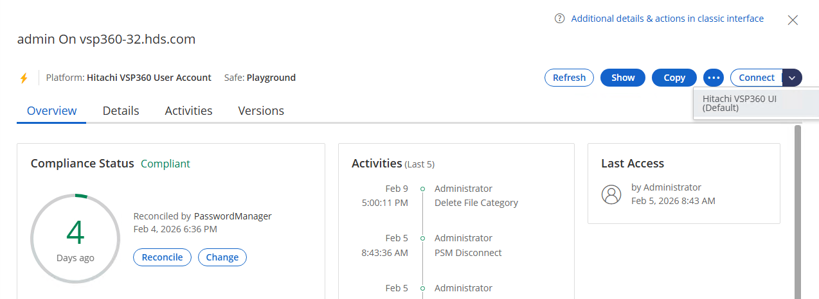

Authentication and Authorization Model
- All VSP 360 API calls require a JWT access token.
- Tokens are issued by VSP 360 Keycloak and are short-lived.
- The service account used by CyberArk must be assigned the pam:management role.
- Passwords and secrets are never returned by any GET API.

Security Best Practices
- Always use TLS/HTTPS for API communication.
- Assign the minimum required roles to PAM service accounts.
- Store all secrets only in CyberArk vaults.
- Enable auditing and review PAM logs regularly.
- Avoid sharing service account credentials outside CyberArk.

Summary
The VSP 360 CyberArk PAM integration provides a secure, automated framework for managing privileged credentials across VSP 360 services, users, and registered block storage devices.
By leveraging CyberArk’s REST API plugin framework and the VSP 360 APIs, organizations can reduce operational risk, enforce security best practices, and maintain continuous compliance.

